Serialism Composition
Serialism (Twelve Tone Row) is a system of composing devised by the 20th Century composer Anton Schoenberg. It uses the 12 notes of the chromatic scale arranged in a series decided by the composer, called a set. Each note can only be used once.

There are four basic forms of the set- Original, Retrograde, Inversion and Retrograde-Inversion. These forms are explained in examples below.

Original:~ The original series, notes 1 – 12 arranged in a certain order.

Retrograde:~ The original series played backwards.

Inversion:~ The original series turned ‘upside down’. In other words, the music starts on the same note but then moves in exactly the opposite direction to the original.

Retrograde-Inversion:~ The inversion played backwards.
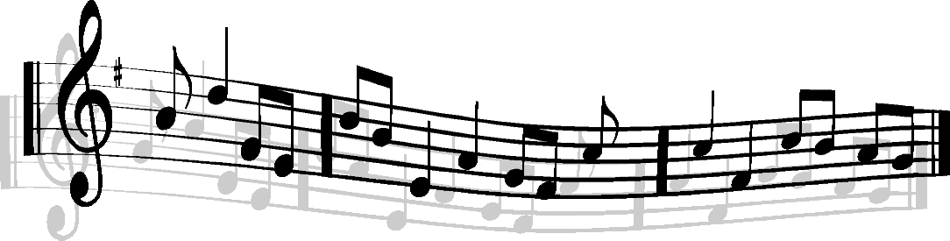

Each form of the row can be transposed 11 times, giving 12 versions in total. Therefore this gives us 48 versions of the row to work with (12x4).

The row can be used:
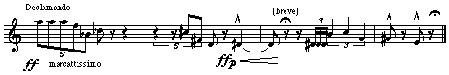
Horizontally:~ to create melodies

Vertically:~ to create chords

Now listen to a few examples of Serial/ Twelve Tone Compositions.


What do you think?


Composing Your Own Serial Row
You are now going to compose your own tone row.

- Start by writing out the chromatic scale of 12 notes in the normal order.

- Now make up your own tone row on the manuscript below. Your notes can be in any order. Ideas for creating your row:~ You could number your original scale 1 – 12 and roll a dice to decide on a new order or place all your note names in a hat and pick them out at random.
TOP TIP:
Cross out the notes of the original chromatic scale as you go, this will prevent you from using the same note twice.

TRY TO GET A ROW THAT IS INDIVIDUAL IN CHARACTER AND THAT IS BALANCED IN SHAPE.
Writing the other form of the set
RETROGRADE:~
Copy out your tone row backwards (the last note will now be the first note).

INVERSION:~
This is the most complicated to work out. Start with your original tone row. The first note should be either an octave above or below the original. From here you will create your row ‘upside down’. This means every interval will be the same but in the opposite direction- so if the original went a fourth up you will write your note a fourth down.

RETROGRADE INVERSION:~
Now write your inversion backwards.

Writing out the transposition of the forms of the set
- There are four sheets of manuscript attached to this booklet. One for each set- Original, Retrograde, Inversion and Retrograde Inversion. Copy your correct tone row at the top of each page.
- Underneath each of these forms you are now going to write 11 transpositions of each tone row. Moving up 1 semitone every time. Make sure you keep all the notes in each stave in alignment with each other.

- When you have completed the above you should have 12 versions of each basic form of the tone row, a total of 48 versions of the row!

Using the Serial Tone Row to Compose a piece of Music

- Decide what form or structure you want your piece to use (e.g. Ternary, Minuet and Trio, Rondo etc.) It might reflect the structure of the row. Also decide what features/devices you might use in each section and also the texture (e.g. homophonic- by using vertical rows to create chords / polyphonic- by using horizontal rows to create melodies).
- Now try to write a melody using two or three of the 48 versions of the row you have just written out for your first section of your piece (i.e. section A). Try to use a variety of rhythms – the melody should be about 8 bars long.

THINK ABOUT:~
Time Signature, Note values, Rests, Clefs, Which instrument will have the melody? Ties, Chords, Intonation (legato/ staccato markings) Accents, Dynamics, Tempo, Phrasing, Flow

Remember: No note should appear out of turn, although notes CAN be immediately repeated. Notes of the row can be used at any octave.
- Now try to write a different 8 bar melody using another two or three of the 48 versions of your row for the second section of your piece.
Remember: This version should be a contrast to the first – in mood, rhythm, dynamics and shape.
- Now decide what instruments (I would suggest between 1 – 3 no more or it might get complicated) you want to use for your piece. On Sibelius start a score with your chosen instruments and time signature. Fill in your melody for section A and B.
- You can now start filling in the other instruments to create harmonies or chords using any of your tone rows. Look at other composers work for some rhythmic inspiration.
- Look carefully at the structure of your piece. How will you extend your melody. Will you use completely new melodic material or repeat existing material.
TOP TIP:~
Your piece should last roughly 1 minute. A ternary piece (Section A B A) with each section lasting approximately 8 bars should be around 1 minute.

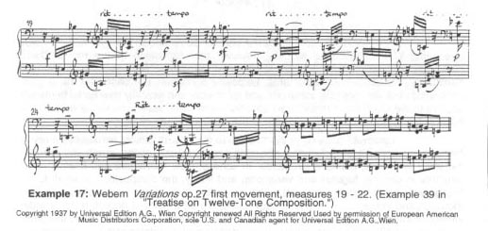
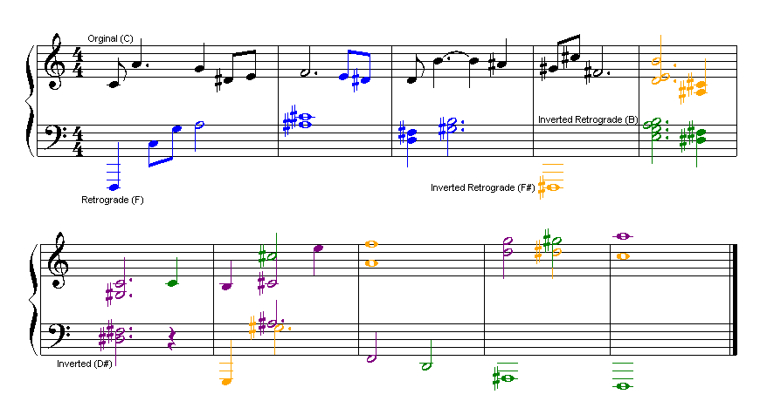

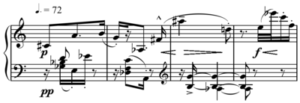

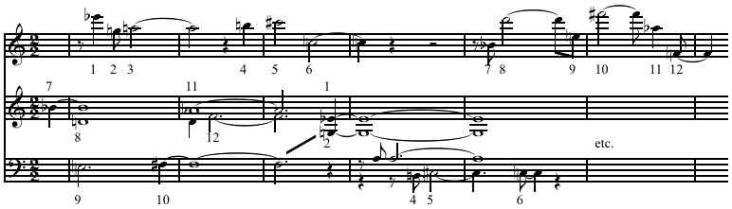

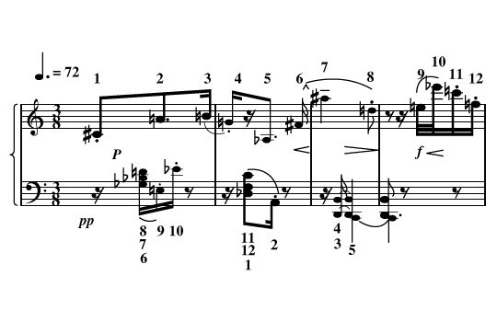

TOP TIPS FOR A SUCCESSFUL SERIAL COMPOSITION
- Think of a clever title which will help form the basis of your composition. (A good title/ stimulus can help shape your journey.)
- Decide upon the form of your composition.
- Consider which instruments to use. E.g. strings and percussion work well together. Try unusual combinations.
- Exploit the full range of the instrument.
- Experiement with pizzicato/ staccato/ tremolando/ rolling/ accents, etc.
- Consider texture – homophonic/ polyphonic/ note clusters/ rhythmic imitation.
- Use the rows in different ways – e.g. vibraphone plays the original row, underneath the ‘cello plays the retrograde inversion.
- Create tension with a pedal or inverted pedal.
- Be bold with dynamics
- Use interesting and exciting rhythms and don’t forget the importance of rests!
- Make use of changing time signatures – expect the unexpected.
- Use “plain system text” on Sibelius to show which note row you are using. (When you write your programme note you can easily identify what you used and then justify your decisions.)

EXEMPLIFICATION OF GOOD PRACTICE
If you are struggling to come up with an idea or a starting point, look at the following plan. You can use this idea or create your own plan.

TITLE: MIDNIGHT CHASE

INSTRUMENTS: Flute, Glockenspiel and Vibraphone
FORM: Ternary
KEY: Atonal
TIME SIGNATURE: Start in 4/4. Set the tempo at a slow moderate
speed. (in the B section go wild! Change to one bar
of 6/8, the next bar to 3/4). Insert a tempo change

1. Section A – set the scene. A clock strikes midnight. Have a pedal and/or an inverted pedal as another instrument chimes.
2. Section B – a chase scene. Set a faster tempo with irregular meters.
3. Return to your ideas in Section A, but make some changes to maintain interest. Add a coda and consider how you want your composition to end.
4. Ensure your score includes dynamics and phrasing. Careful consideration of these elements can significantly enhance your efforts!
PROGRAMME NOTE: This is a piece of programme music – it tells a story. Describe what you have done and justify your reasons for doing so. E.g. the rapid arpeggios represent the chase from the murder scene.
Back up everything you have done. Be imaginative and creative and focus on atmosphere.
Use higher concepts where applicable – homophonic, polyphonic, serialism, versions of note row, etc.

